ASSIGNMENT-4.2
Name: K.Lokesh Course name:AI Assistant coding
Ht.No : 2303A51434 Bt no: 21
Lab 4: Advanced Prompt Engineering – Zero-shot, One-shot, and Few-shot Techniques
Task Description-1
- Zero-shot: Prompt AI with only the instruction. Write a Python function to determine whether a given number is prime
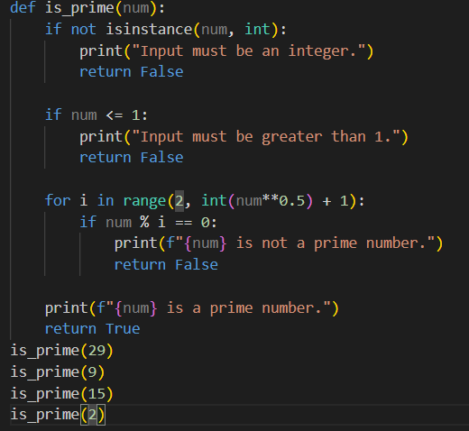
Output:
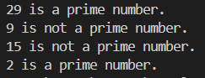

Task Description-2
- One-shot: Provide one example: Input: [1, 2, 3, 4], Output: 10 to help AI generate a function that calculates the sum of elements in a list.
Output:
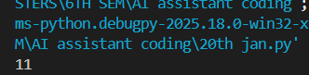
Task Description-3
- Few-shot: Give 2–3 examples to create a function that extracts digits from an alphanumeric string.
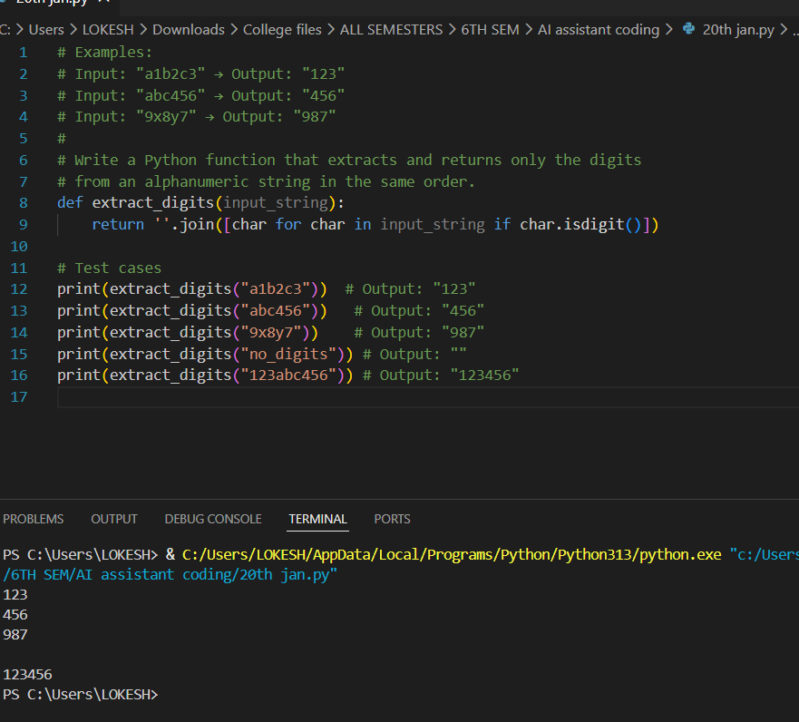
Task Description-4
- Compare zero-shot vs few-shot prompting for generating a function that counts the number of vowels in a string.
Zero-shot:
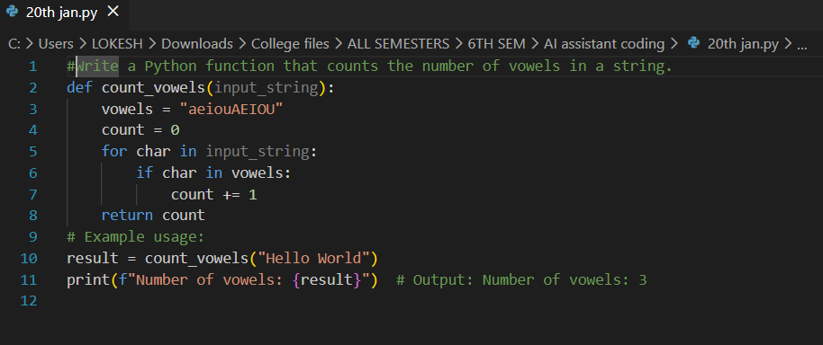
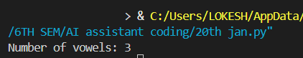
Few-Shot:
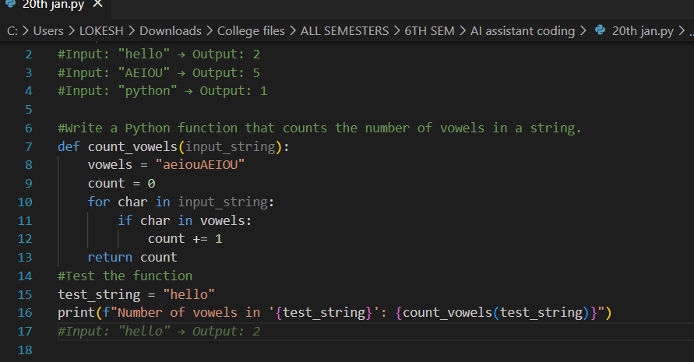

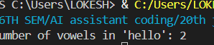
Explaination:
The zero-shot prompt generated a correct but lengthy solution using basic logic. The few-shot prompt, supported by examples, helped the model understand the pattern clearly and produce a shorter and more optimized solution. Thus, examples improve both clarity and efficiency of the output.

Task Description-5
- Use few-shot prompting with 3 sample inputs to generate a function that determines the minimum of three numbers without using the built-in min() function.
